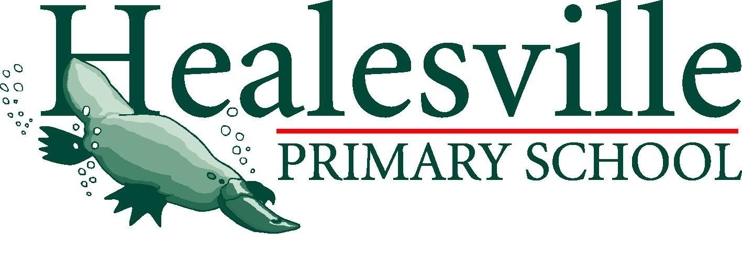
Ratified: Term 2, 2016
To be reviewed: Term 3, 2019

Food Policy

Purpose
Eating a healthy diet helps children stay alert during class, promotes health and wellness and assists in developing healthy habits to become healthy adults. School children get up to one third of their daily energy requirements at school; which makes schools an important place for learning healthy eating habits. The school environment should promote and model healthy eating and good nutrition in all aspects in which food and drink is introduced into the school. The purpose of this policy is to create an environment and ongoing opportunities for children to access healthy food and promote their health and wellbeing.
Objectives and Procedures
Healthy food choices should be implemented in all aspects of school life and activities. This policy does not aim to retract all unhealthy food provided in these events, however an emphasis should be placed on providing and advocating for healthier options.
Guidelines
Whole School
1.1 Any activities and programs within the school setting relating to or involving food and drink should promote healthy eating and good nutrition to students.
1.2 Staff and the wider school community are involved in guiding the development and implementation of the whole school healthy eating policy and are key partners in promoting and supporting healthy eating initiatives in the school.
1.3 Staff and the wider school community are provided with information about policy requirements.
1.4 School activities that involve the provision of food will address the requirements of the Anaphylaxis Procedures for Schools and any other known allergies.

1.5 Principals are responsible for ensuring the requirements of the policy, guidelines and relevant legislation are met. Principals are responsible for ensuring that school policies and practices are consistent with the nutrition in schools policy and are responsive to local needs, including cultural diversity.

1.6 Families are encouraged to provide healthy lunchboxes. Healthy food options are encouraged for staff at meetings, professional learning events and in the staff room.

1.7 Safe drinking water is available at all times, and only water bottles filled with water are to be accessed during class.

1.8 Students are given adequate time to eat their food in suitable and inviting eating spaces, which encourage the social interaction of students.

1.9 Staff and families are encouraged to foster a healthy body image and enjoyment of eating. This should be conducted through the use of positive language.

1.10 The school respects and celebrates the cultural diversity of its community through recognising and valuing cultural and traditional beliefs about food.

1.11 Staff are supported to access resources, tools and professional learning to enhance their knowledge and capacity to promote healthy eating across the curriculum.

1.12 Families are encouraged to be involved in healthy eating initiatives at school.

1.13 Caffeinated drinks are not to be provided to, or sold to students.

Procedure 2-School Canteen
2.1 Canteen should work toward providing >50% green, <50% amber and 0% red food categories sold at school; to comply with standards set out by The Healthy Eating Advisory Service which is supported by the Victorian Government and partners.
2.2. All sugar sweetened drinks that are categorised in the occasional (red) food categories outlined in the Go for your life- food categories document, are not permitted for sale in school canteens.
2.3 Canteen staff will ensure canteen operations and food items are reviewed annually to ensure that the recommended food items are present in their correct proportions (see 2.1).
2.4 Where possible Healesville Primary School use wholemeal breads, pastas, rice and uses only low sodium, fat and sugar products to create homemade food.

Procedure 3- School Events
3.1 Where school activities involve the provision of food and drink to the wider school community, consideration should be given to modelling and promoting healthy eating.
3.2 All school activities that involve the provision of food and drink to students should be consistent with the Go for your life- food categories document
3.3 Off site school activities that involve the provision of food and drink to students, including excursions, camps and school functions should consistent of mostly green and amber categories outlined in the Go for your life- food categories document. Green food choices should be the most abundant food category.
3.4 Class parties should focus on ensuring healthy options are available based on the traffic light system. No soft drinks or caffeinated drinks are to used.

Procedure 4- Fundraising
4.1 Foods that are used as fundraising items will comply with green and amber category foods at all times or 80% of the time.
4.2 Only undertake 3 fundraisers using red category foods per year (inclusive 4.3b).
4.3b Chocolate or confectionery drives will be limited to no more than one per year. Families will not be pressured to take boxes of chocolate/confectionery and families will receive a maximum of one box each. Families will be given the choice of donating the amount equivalent to the profit from a box of chocolates but not take the box.
4.4 Our school will endeavour to run at least one fundraiser each year that supports our local fruit and vegetable industry.
4.5 Every opportunity will be taken to improve the healthiness of the food provided as a fund raiser. For example using wholemeal bread where possible, selling juice or smoothies instead of soft drink.

Procedure 5- Classrooms
5.1 Healthy eating is incorporated into the curriculum, across multiple key learning areas. Teaching and learning and all class activities in all other key learning areas should reinforce healthy eating and good nutrition wherever possible.
5.2 The health and wellbeing of students is relevant to their learning and is important to schools. The present and future health of students can be enhanced by quality learning and positive experiences at school.
5.3 Foods provided to students in class should promote healthy eating practices and comply with the proportions of food categories recommended to the canteen (see 2.1). This includes class parties and class food activities.
5.4 Food and drink, food vouchers and sweets are not used as an incentive or reward on a regular basis.
5.5 Sweet drinks are not permitted during class time.

This policy should be read in conjunction with:
- Australian Dietary Guidelines
http://www.nutritionaustralia.org/national/resource/australian-dietary-guidelines-2013

- Healthy Canteen Kit: School canteens and other school food services policy
http://www.education.vic.gov.au/Documents/school/principals/management/gfylpolicy.pdf

- Go for your life- food categories
http://www.education.vic.gov.au/Documents/school/principals/management/gfylplancat.pdf
Healesville Primary Student Welfare Policy

